Structural Design Patterns:

Structural Patterns are concerned about providing solutions and efficient standards regarding class compositions and object structures.

Also, they rely on the concept of inheritance and interfaces to allow multiple objects or classes to work together and form a single working whole.

The main motive behind using this pattern is to convert an existing interface into another interface that the client expects.

It's usually implemented once the application is designed.

The following are list of Structural design Patterns

1. Adapter
2. Bridge
3. Filter
4. Composite
5. Decorator
6. Façade
7. Flyweight
8. Proxy

#### **Adapter Pattern:**

The adapter design pattern is a structural design pattern that allows two unrelated/uncommon interfaces to work together. In other words, the adapter pattern makes two incompatible interfaces compatible without changing their existing code.

Adapter is about creating an intermediary abstraction that translates, or maps, the old component to the new system. Clients call methods on the Adapter object which redirects them into calls to the legacy component. This strategy can be implemented either with inheritance or with aggregation.

Adapter functions as a wrapper or modifier of an existing class. It provides a different or translated view of that class.

### **When to Use Adapter Pattern**

* **When an outside component provides captivating functionality that we'd like to reuse, but it's incompatible with our current application**. A suitable Adapter can be developed to make them compatible with each other
* When our application is not compatible with the interface that our client is expecting
* When we want to reuse legacy code in our application without making any modification in the original code

### **Adapter Pattern Example**

Consider a scenario in which there is an app that's developed in the US which returns the top speed of luxury cars in miles per hour (MPH). Now we need to use the same app for our client in the UK that wants the same results but in kilometers per hour (km/h).

To deal with this problem, we'll create an adapter which will convert the values and give us the desired results:

[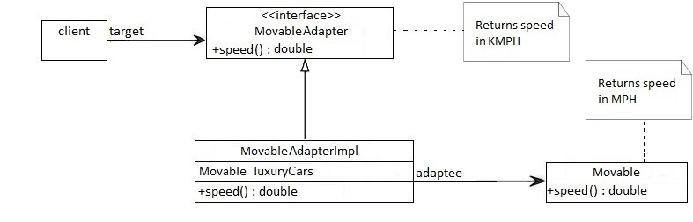](https://www.baeldung.com/wp-content/uploads/2017/09/Rpt_ER5p.jpg)